NORMALIZATION EXERCISE

Joe's Video Store — View 1
Customer Rents Video · Individual work

Overview
Scenario
Joe wants you to develop a small database application to help him run his video rental store. Tracking information to rent a video is one system requirement.
Your Task
You are to develop a view schema in 3NF for the Customer Rents Video view. You will show the schema in ERD notation and document any assumptions you make.
Format: Individual work

The Source Document
Joe's Video Store: Video Rentals
Transaction ID: 1 | Date: May 18, 2006
Customer ID: 12345 | Name: Mira Washington
Phone: 962-6190 | Address: 76 Pacific Ave, My Town, Alberta, T3J 2X0

Video ID | Copy Number | Title | Return Date | Rental Charge
Hor-1 | 1 | Carrie | May 21, 2006 | $3.00
Hor-2 | 3 | The Exorcist | May 21, 2006 | $3.00
Rom-1 | 1 | As Good As It Gets | May 19, 2006 | $5.00

Subtotal: | $11.00
GST: | $0.77
Total: | $11.77
Business Rules
1. A customer may have a maximum of ten videos rented simultaneously.
2. Joe knows the rental charges change over time, so he wants the system to record the rental charge for each video on a transaction (historical information) as well as record the current rental charge for each video.
3. Transaction ID, Customer ID, and Video ID are unique.
4. Copy Number is unique within Video ID (the first copy of any given video is copy number 1).
Step 0 — Create the Initial Table (0NF)
What to do
1. List all data items from the source document.
2. Identify the primary key (underlined).
3. Identify any repeating groups (place in parentheses).
Attributes to include
Attribute
Transaction ID
Transaction Date
Customer ID
Customer First Name
Customer Last Name
Customer Phone
Customer Street Address
Customer City
Customer Province
Customer Postal Code
Video ID
Video Copy Number
Video Title
Video Return Date
Video Rental Charge Current
Video Rental Charge Historical
Transaction GST

Hint: The repeating group is the set of video attributes that can have multiple values for a single transaction.
Write your 0NF table here:
Transaction(Transaction ID(Transaction Date))
Customer(Customer ID(Customer First Name, Customer Last Name, Customer Phone, Customer Street address, Customer City, Customer Province, Customer Postal Code))
Video(Video ID(Video Copy Number, Video Title, Video Return Date, Video Rental Charge Current, Video Rental Charge Historical, Transaction GST))

Step 1 — Apply First Normal Form (1NF)
Rules
1. A table must contain only atomic attributes.
2. A table cannot contain any repeating groups.
What to do
1. Fix composite attributes:
a. Customer Name should be split into Customer First Name and Customer Last Name.
b. Customer Address should be split into Street Address, City, Province, and Postal Code.
2. Remove the repeating group:
a. Move Video ID, Video Copy Number, Video Title, Video Return Date, Video Rental Charge Current, and Video Rental Charge Historical to a new table.
b. Copy the primary key (Transaction ID) into the new table as a foreign key.
3. Designate a primary key for the new table:
. The new table (Transaction Detail) needs a primary key. Consider:
. Can Transaction ID alone uniquely identify a row? (No — one transaction can have many videos)
. Can Video ID alone uniquely identify a row? (No — one video can appear in many transactions)
. Can Video ID + Copy Number alone uniquely identify a row? (No — the same video copy can be rented multiple times)
What combination works? Transaction ID + Video ID + Copy Number
Write your 1NF tables here:
Table 1: Transaction
Transaction ID (PK), Transaction Date, Customer ID, Customer First Name,
Customer Last Name, Customer Phone, Customer Street Address, Customer City,
Customer Province, Customer Postal Code, Transaction GST
Table 2: Transaction Detail
Transaction ID (FK), Video ID, Video Copy Number, Video Title, Video Return Date,
Video Rental Charge Current, Video Rental Charge Historical
Table 3: ??? (Do you need a separate Video table?)
Hint: The video title and current rental charge depend only on Video ID — not on the whole primary key of the Transaction Detail table. This will be addressed in 2NF.
Step 2 — Apply Second Normal Form (2NF)
Rule
All non-key attributes must fully depend on the entire primary key.
A 2NF violation can only occur in a table with a composite primary key.
• Transaction table has a single PK (Transaction ID) → No 2NF violation possible
• Transaction Detail table has a composite PK (Transaction ID + Video ID + Copy Number) → Must evaluate

What to do
1. Evaluate each non-key attribute in Transaction Detail:
Attribute | Depends on Transaction ID? | Depends on Video ID? | Depends on Copy Number? | Fully Dependent on Entire PK?
Video Title | No | Yes | No | No — Partial Dependency!
Video Return Date | No | No | No | Yes
Video Rental Charge Current | No | Yes | No | No — Partial Dependency!
Video Rental Charge Historical | No | No | No | Yes

2. Fix the partial dependency:
a. Remove Video Title and Video Rental Charge Current from Transaction Detail.
b. Place them in a new table called Video.
c. Video ID becomes the primary key of the Video table.
d. Video ID remains in Transaction Detail as a foreign key.
Write your 2NF tables here:
Table 1: Transaction
Transaction ID (PK), Transaction Date, Customer ID, Customer First Name,
Customer Last Name, Customer Phone, Customer Street Address, Customer City,
Customer Province, Customer Postal Code, Transaction GST
Table 2: Transaction Detail
Transaction ID (FK), Video ID (FK), Video Copy Number, Video Return Date,
Video Rental Charge Historical
Table 3: Video
Video ID (PK), Video Title, Video Rental Charge Current
Step 3 — Apply Third Normal Form (3NF)
Rule
A non-key attribute cannot be fully dependent on another non-key attribute.
A table must have two or more non-key attributes for a violation of 3NF to occur.

What to do
1. Evaluate each table for transitive dependencies:
Table | Non-Key Attributes | Violation?
Transaction | Transaction Date, Customer ID, Customer First Name, Customer Last Name, Customer Phone, Customer Street Address, Customer City, Customer Province, Customer Postal Code, Transaction GST | Yes — Customer ID is a non-key attribute, and Customer First Name, Last Name, Phone, Street Address, City, Province, and Postal Code all depend on Customer ID
Transaction Detail | Video Return Date, Video Rental Charge Historical | No — only two non-key attributes, but they don't depend on each other
Video | Video Title, Video Rental Charge Current | No — no dependency between them

2. Fix the transitive dependency in Transaction:
a. Customer ID is a non-key attribute in the Transaction table.
b. Customer First Name, Last Name, Phone, Street Address, City, Province, and Postal Code all depend on Customer ID.
c. Remove these attributes from Transaction and place them in a new table called Customer.
d. Customer ID becomes the primary key of the Customer table.
e. Customer ID remains in Transaction as a foreign key.
Write your 3NF tables here:
Table 1: Transaction
Transaction ID (PK), Transaction Date, Customer ID (FK), Transaction GST
Table 2: Customer
Customer ID (PK), Customer First Name, Customer Last Name, Customer Phone,
Customer Street Address, Customer City, Customer Province, Customer Postal Code
Table 3: Transaction Detail
Transaction ID (FK), Video ID (FK), Video Copy Number, Video Return Date,
Video Rental Charge Historical
Table 4: Video
Video ID (PK), Video Title, Video Rental Charge Current
Step 4 — Draw the ERD
What to do
1. Draw each table as a box.
2. List attributes inside each box.
3. Underline the primary key.
4. Mark foreign keys with (FK).
5. Draw relationship lines between tables.
6. Add cardinality symbols (1, M).
ERD Layout
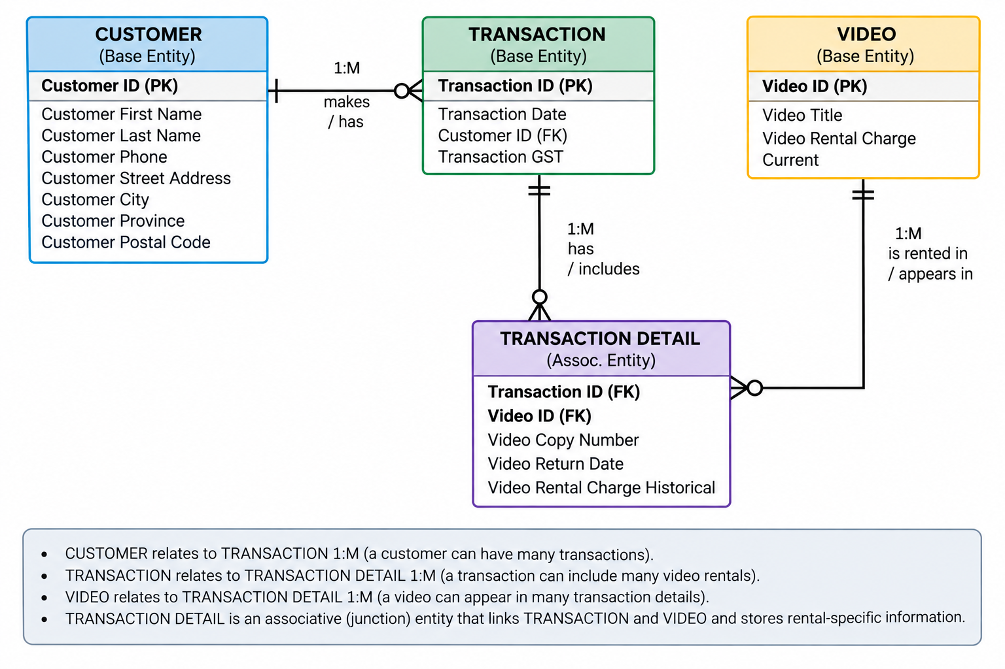
Relationships
Entity A | Relationship | Entity B | Type
CUSTOMER | makes | TRANSACTION | 1:M
TRANSACTION | contains | TRANSACTION DETAIL | 1:M
VIDEO | appears in | TRANSACTION DETAIL | 1:M
Assumptions to Document
Write down any assumptions you made during the normalization process.
Examples
1. A transaction can contain multiple videos (M:N relationship between Transaction and Video).
2. The rental charge for a video can change over time, so we store the historical charge in Transaction Detail and the current charge in Video.
3. Video ID + Copy Number uniquely identifies a physical copy of a video.
4. A customer can have many transactions, but each transaction belongs to one customer.
5. GST is calculated per transaction, not per video.
Write your assumptions here:
Submission Requirements
Create
1. Your 0NF table (initial table)
2. Your 1NF tables
3. Your 2NF tables
4. Your 3NF tables
5. Your ERD (hand-drawn or digital)
6. Your documented assumptions
Format
- Handwritten or typed
- Clear labels for PK, FK, and composite keys
- Underline primary keys
- Use parentheses for repeating groups in 0NF
Hints and Tips
Tip | Explanation
Start with 0NF | List everything first. Don't try to organize until you see all the data.
Underline the PK | In 0NF, the PK is Transaction ID (each transaction is one row).
Parentheses for repeating groups | The video information repeats for each video in the transaction.
Fix composite attributes first | Customer Name → First Name + Last Name; Address → Street, City, Province, Postal Code.
Move repeating groups to new tables | Copy the PK as a FK.
Check for partial dependencies | In tables with composite PKs, ask: "Does this attribute depend on only part of the PK?"
Check for transitive dependencies | Ask: "Does this non-key attribute depend on another non-key attribute?"
Draw the ERD last | Once your tables are in 3NF, the ERD is easy to draw.
Document assumptions | If you had to make a decision (e.g., "a transaction can have many videos"), write it down.

Common Mistakes to Avoid
Mistake | How to Avoid
Forgetting to split composite attributes | Always check: Can this attribute be broken down into meaningful parts?
Not identifying the repeating group correctly | Look for attributes that have multiple values for a single transaction.
Choosing the wrong PK for the new table | Ask: What combination of attributes uniquely identifies each row?
Missing a partial dependency | In composite PK tables, check each non-key attribute against each part of the PK.
Missing a transitive dependency | In tables with 2+ non-key attributes, check if one depends on another.
Forgetting to mark FKs in the ERD | Every relationship needs a FK in the child table.
Not documenting assumptions | Write down every decision you make.

Example of What Your Work Should Look Like
0NF
Transaction(Transaction ID, Transaction Date, Customer ID, Customer First Name,
Customer Last Name, Customer Phone, Customer Street Address, Customer City,
Customer Province, Customer Postal Code, (Video ID, Video Copy Number, Video Title,
Video Return Date, Video Rental Charge Current, Video Rental Charge Historical),
Transaction GST)
1NF
Transaction(Transaction ID, Transaction Date, Customer ID, Customer First Name,
Customer Last Name, Customer Phone, Customer Street Address, Customer City,
Customer Province, Customer Postal Code, Transaction GST)

TransactionDetail(Transaction ID (FK), Video ID, Video Copy Number, Video Title,
Video Return Date, Video Rental Charge Current, Video Rental Charge Historical)
2NF
Transaction(Transaction ID, Transaction Date, Customer ID, Customer First Name,
Customer Last Name, Customer Phone, Customer Street Address, Customer City,
Customer Province, Customer Postal Code, Transaction GST)

TransactionDetail(Transaction ID (FK), Video ID (FK), Video Copy Number,
Video Return Date, Video Rental Charge Historical)

Video(Video ID, Video Title, Video Rental Charge Current)
3NF
Transaction(Transaction ID, Transaction Date, Customer ID (FK), Transaction GST)

Customer(Customer ID, Customer First Name, Customer Last Name, Customer Phone,
Customer Street Address, Customer City, Customer Province, Customer Postal Code)

TransactionDetail(Transaction ID (FK), Video ID (FK), Video Copy Number,
Video Return Date, Video Rental Charge Historical)

Video(Video ID, Video Title, Video Rental Charge Current)
ERD
[Draw the ERD showing Customer, Transaction, TransactionDetail, and Video tables with relationships]

